EARTH SCIENCE COURSE UNITS  Below is a list of course units that will be covered this year.  - Density and Connections  - Astronomy  - Earth’s Motions in Space  - Mapping the Earth  - Earth’s Internal Structure and Earthquakes  - Minerals  - Rocks  - Plate Tectonics  - Weathering  - Erosion, Deposition, and Landscapes  - Geologic History  - The Hydrologic Cycle  - Weather and Climate |  |  | READY TO BEGIN?  If you have read and understand the contents of this document, please sign below.  ______________________________________________________ Parent Signature  ______________________________________________________ Student Signature  Questions? Comments? Please write them below. __________________________________________________________________________________________________________________________________________________________________________________________________________________________________________________________________________________________________________________________________________________________________________________________________________________________________________________________________________________________________________________________________________________ |  | REGENTS EARTH SCIENCE  - Edison Career and Technology High School  - Rochester City School District  - 2017 – 2018 School Year  - Mr. Burgess  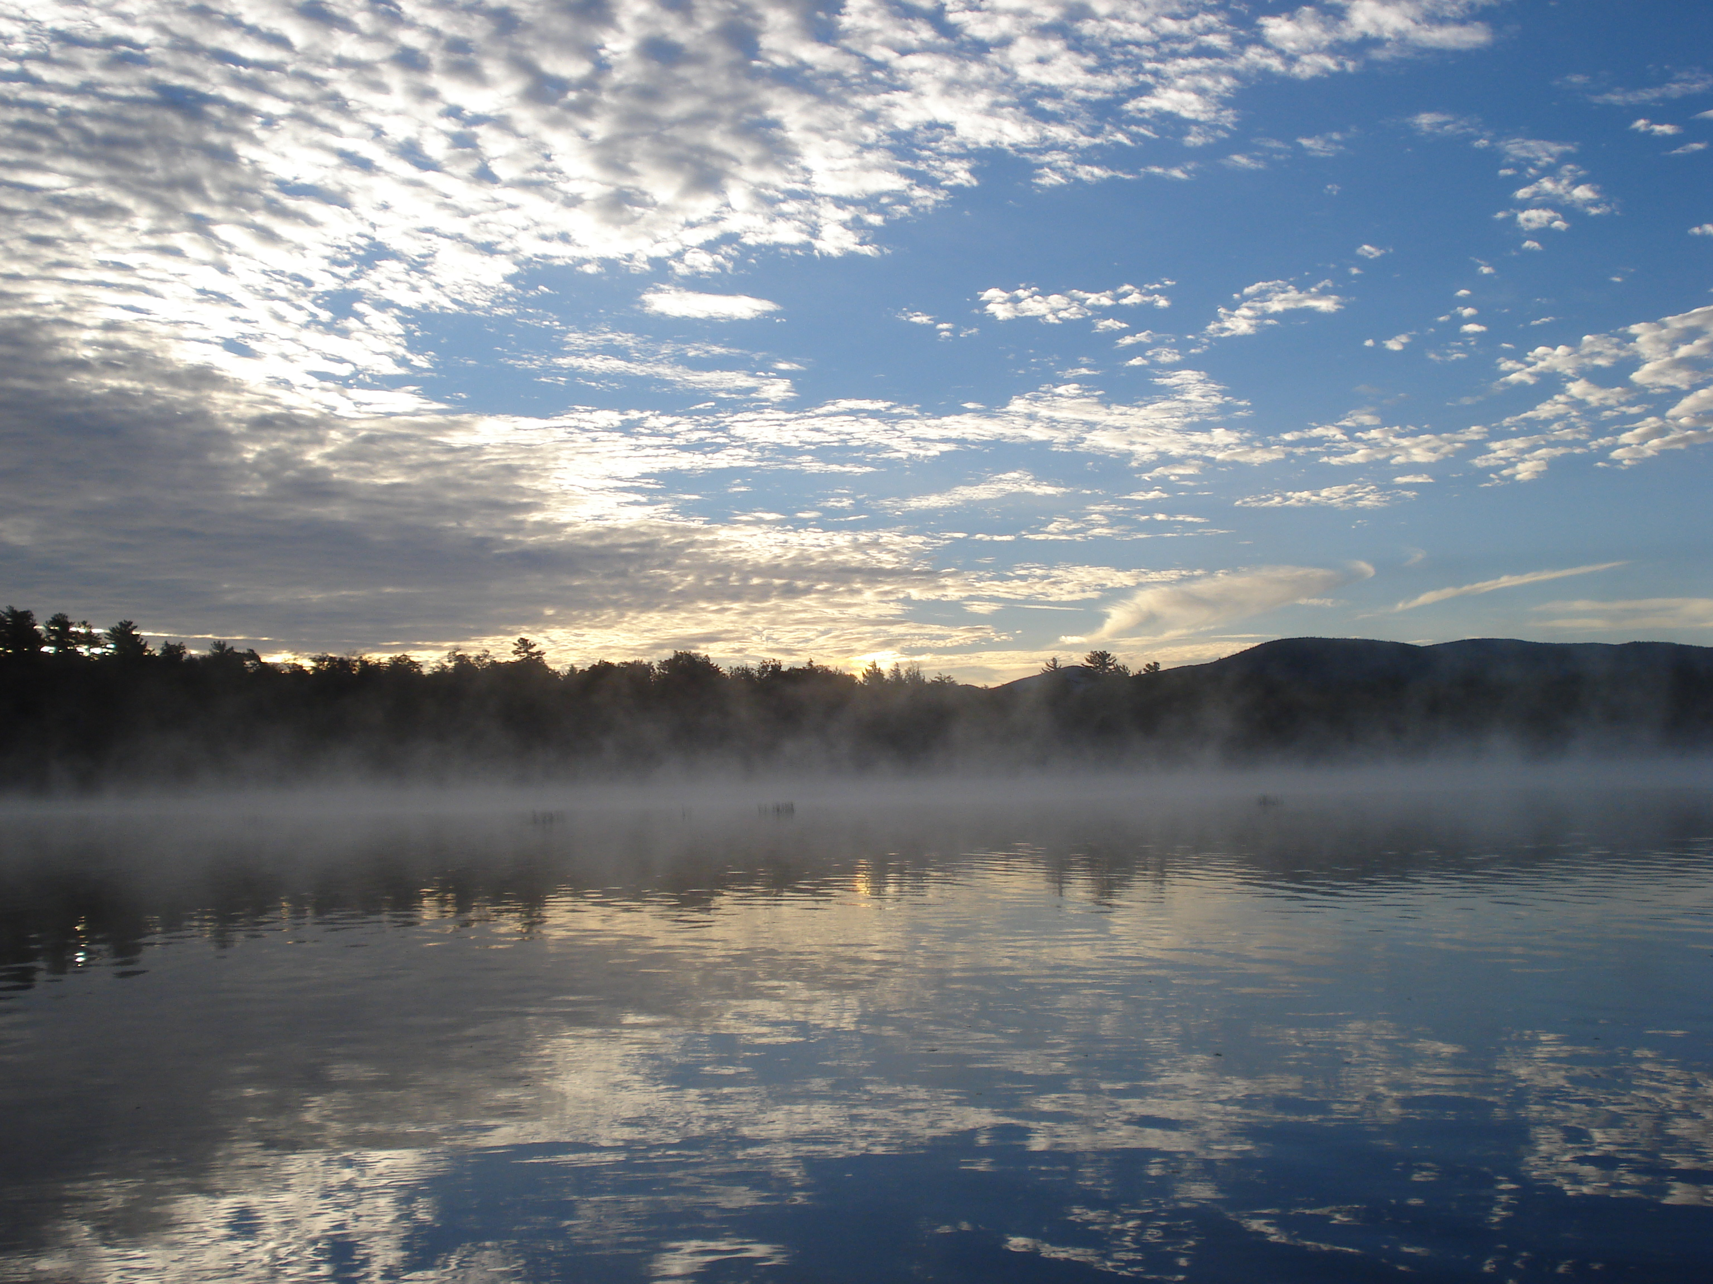

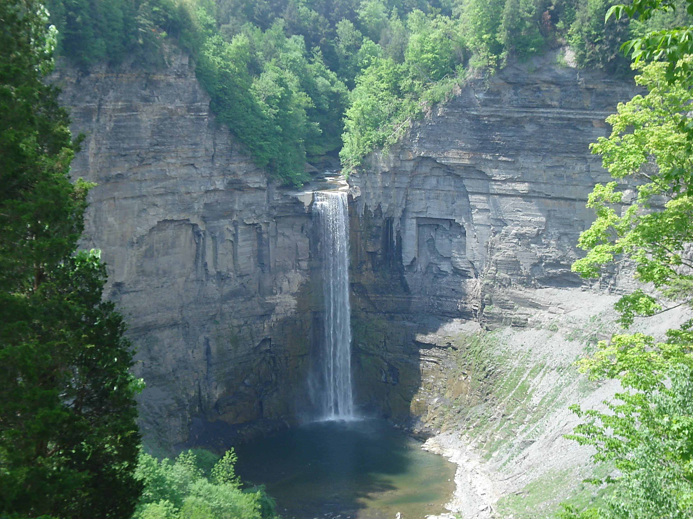  NEW YORK STATE LABORATORY QUALIFICATION REQUIREMENT  The New York State laboratory requirement is very demanding of students. Each student must have completed a minimum of 1200 laboratory minutes in class in order to be eligible to sit for the June Regents examination. When this requirement is complete it will prove to have been a rewarding experience and one which you have seen your skills in scientific coursework improve significantly.  Conditions  1. If you miss a lab for any reason, it is your responsibility to make arrangements with your instructor to successfully complete any missing portion of the lab.  2. You must be lab qualified by the end of the month of May in order to take the June Regents Examination. Labs will not be accepted after this date.  3. Labs are not to be taken from the classroom for any reason other than for collecting data. | “A river cuts through a rock, not because of its power but its persistence.”  -Jim Watkins  CLASSROOM EXPECTATIONS  - Arrive on time, prepared to work with a folder and something to write with. I will not be providing these things to you. You must keep a copy of your Earth Science Reference Tables with you at all times and bring it every day.  - Complete course work by the due date that is set.  - If you must miss class, it is your job to see me about missed material and assignments. Do not fall behind.  - Please participate when asked. If you are called on in class it is not to embarrass you. Instead, it is to drive instruction and check for understanding. Ask questions when needed. Don’t let these things slide and discover that you missed passing the final by a point or two. It is OK to ask for help!  - Treat everyone in the room with respect.  - Treat all materials in the room with respect.  - Make sure your work station is clean when you leave the room.  - Do not eat or drink in class. |  | KEEP UP ON YOUR WORK  I teach Earth Science and distribute assignments to support your learning in a variety of ways. How much you learn is primarily dependent upon you, but consider me as a resource to support you along the way. If you have questions or begin to struggle, you must ask for help. If you miss bits and pieces of the course, your overall understanding and appreciation of Earth Science will be greatly diminished. In addition, make sure you are completing assignments as they are given to you. Refer to the calendar for these due dates, but keep in mind that they only really benefit you by being completed before the particular unit exam which covers that content. My grading policy is below.  GRADE BREAKDOWN  60% Tests and Quizzes  20% Classwork  10% Labs  10% Homework  CONTACT ME  The best way to get ahold of me is through my district email at David.Burgess@rcsdk12.org I will check this each night.  WEBSITE  Review content, play review games, download review packets, read the reference tables and more on our classroom website: www.rcsdk12.org/mrburgess

